Hart Publishing is very pleased to announce the publication of the 2nd edition of Contract Law Hugh Beale, Bénédicte Fauvarque-Cosson, Jacobien Rutgers, Denis Tallon and Stefan Vogenauer

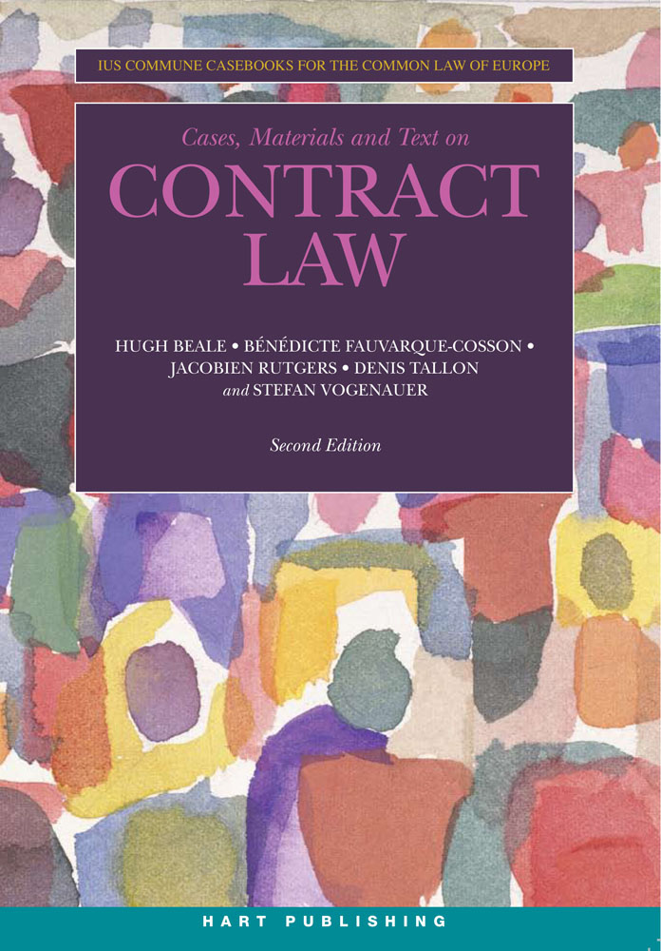
This is the second edition of the widely acclaimed and successful casebook on Contract in the Ius Commune Series, developed to be used throughout Europe and aimed at those who teach, learn or practise law with a comparative or European perspective. The book contains leading cases, legislation and other materials from the legal traditions within Europe, with a focus on English, French and German law as the main representatives of those traditions. The book contains the basic texts and contrasting cases as well as extracts from the various international restatements (the Vienna Sales Convention, the UNIDROIT Principles of International Commercial Contracts, the Principles of European Contract Law, the Draft Common Frame of Reference and so on). Materials are chosen and ordered so as to foster comparative study, and complemented with annotations and comparative overviews prepared by a multinational team. The whole Casebook is in English.

The principal subjects covered in this book include: General (including the distinctions between Contract and Property, Tort and Restitution) ; Formation; Validity; Interpretation and Contents; Remedies; Supervening Events; and Third Parties.

Click here to view the table of contents

The Authors
Hugh Beale is a Professor of Law at the University of Warwick, and Visiting Professor at the Universities of Amsterdam and Oxford. He is a former Law Commissioner for England and Wales.
Bénédicte Fauvarque-Cosson is Professor of Law at the Université Panthéon-Assas (Paris II).
Jacobien Rutgers is Reader in Law at the Free University of Amsterdam.
Denis Tallon is Professor Emeritus of the Université Panthéon-Assas (Paris II).
Stefan Vogenauer is the Professor of Comparative Law at the University of Oxford, Fellow of Brasenose College and Director of the Oxford Institute of European and Comparative Law.

Nov 2010 1442pp Pbk 9781841136042 £38.95 / €51
Discount Price: £31 / €41

Ius Commune Casebooks for the Common Law of Europe series

___________________________________________________________________________
As a member of the Obligations Discussion Group listserv Hart Publishing is delighted to offer you 20% discount.

Order Online
If you would like to order this title you can do so through the Hart Publishing website.
http://www.hartpub.co.uk/books/details.asp?isbn=9781841136042

To receive the discount please mention ref: ‘ODG’ in the special instructions field. Please note that the discount will not be shown on your order but will be applied when your order is processed.

